Instructional and Other Content Design Plan
Instructional Content
This app will be very similar to other map-based apps (e.g. google maps); therefore, the app should feel familiar and intuitive to use with minimal instructional content. We will not create a stand-alone user guide. Instead, the app will walk first-time users through different functions of the app, as seen in figure 1.

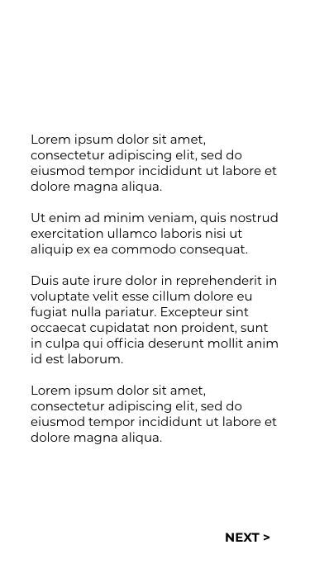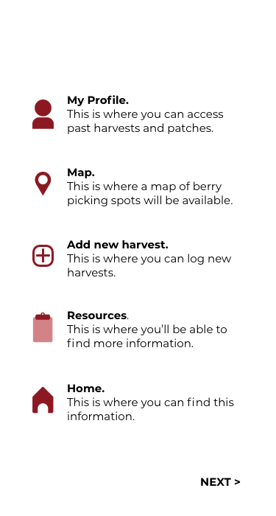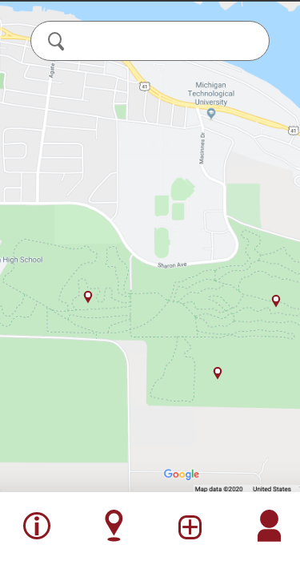
Figure 1: The left view will contain basic instructional information on how to use the app; the middle view will explain the meaning of navigation icons used in the app; the right view will use pop ups for first-time users to explain any map navigation features.

Other Content
There will be information about different types of berries, the Drosophila suzukii fruit fly larvae, and an “about us” page about the scientists. The information about the fruit fly larvae and scientists can be seen in figure 2; the information about different types of berries can be seen in figure 3.

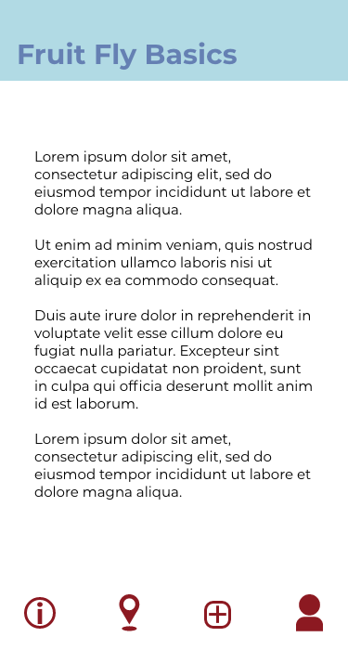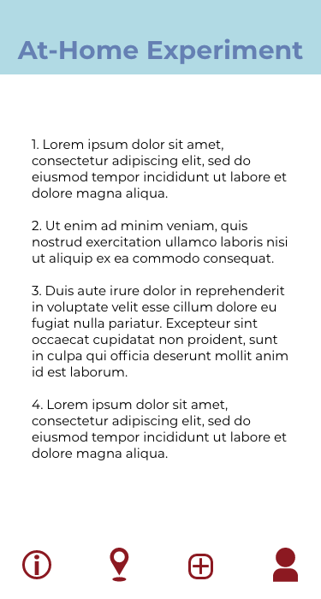
Figure 2: Information on the Drosophila suzukii fruit fly larvae will be shown in the left view; the steps for an at-home test will be shown in the middle view; information on the scientists will be shown in the right view.

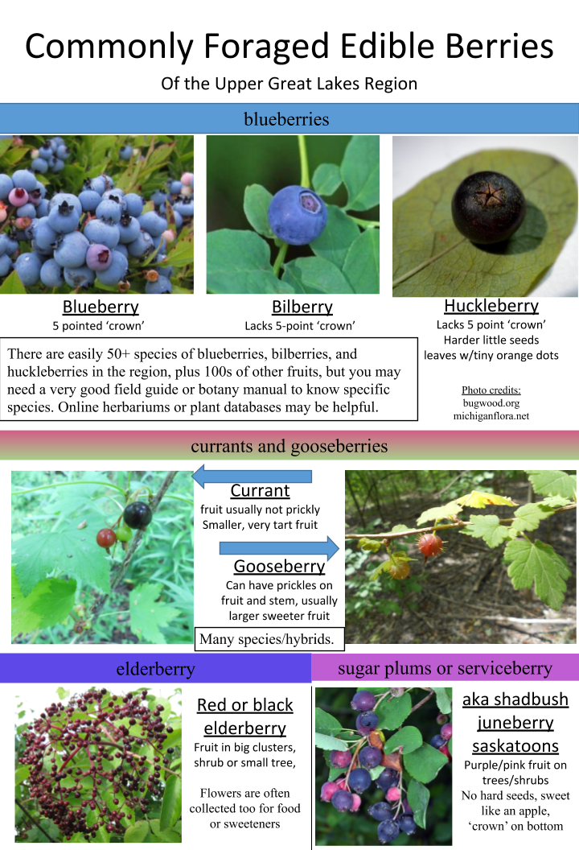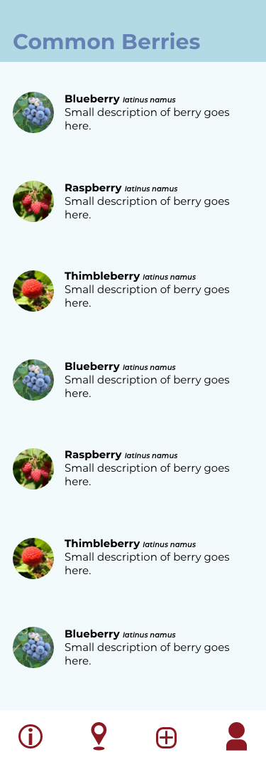
Figure 3: The information shown on the left will be displayed in the view shown on the right, including common names, pictures, and identifiable features.

